Executive Summary: Q4 Fraud Mitigation & Profitability Analysis

Overview
PayFlow Commerce closed Q4 2024 with $7.06M in total revenue, driven by strong holiday market demand. However, a targeted attack on an operations vulnerability drove the fraud rate to 7.03% (Industry Benchmark: <1%). This exposure resulted in $496,406 in losses, reducing Q4 Net Income to just $2,117 and effectively eliminating quarterly profit.

Key Risk Findings
A thorough analysis identified fraudsters are exploiting weekends since there is reduced operational oversight. Attackers are specifically targeting high-value orders when the manual review team is offline. Risk is evenly spread across acquisition channels, but specific product categories are being targeted disproportionately. "Home & Garden" and "Books" are currently sustaining fraud rates exceeding 7%.

- Insight: Transaction risk nearly quadruples when the review team is offline.
- Weekday Fraud Rate: 3.99%
- Weekend Fraud Rate: 13.79%
- Impact: This specific loophole accounted for the majority of the $496k loss.
Machine Learning Solution
I developed and backtested an XGBoost fraud detection model against Q4 data to quantify recoverable revenue.
- Strategy: Moved from a "Hard Block" rule to a "Review Queue.” A 0.50 threshold is recommended to maximize fraud capture while maintaining a manageable false positive rate, ensuring legitimate customer transactions are not unnecessarily blocked.
- Financial Impact: The model successfully flagged $232,000 in recoverable revenue within the Q4 dataset.
- ROI: The projected savings ($232k) outweigh the operational cost of manual reviews ($23k) by a factor of 10x.
Recommendations
- Deploy a "Review Queue": Implement the ML model to route high-risk transactions (>50% probability) to a dedicated "Hold for Review" analyst queue.
- Deploy the XGBoost model to production: Transactions with a predicted fraud probability >90% should be automatically declined.
Q1 Outlook
This recommendation is projected to reduce the fraud rate from 7.03% to 1.3%, restoring Net Income margins to healthy levels.

Appendices

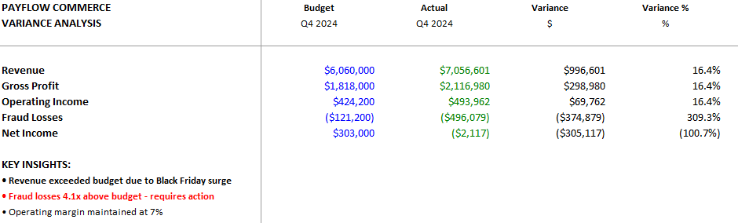
Exhibit A: showing the Profit Wipeout.

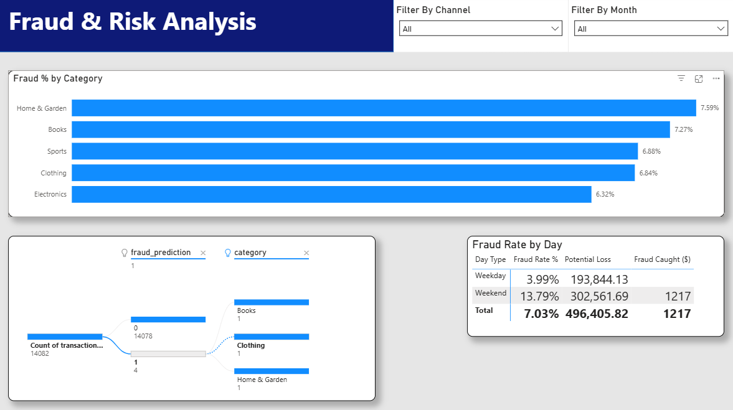
Exhibit B: showing the 13.8% spike.

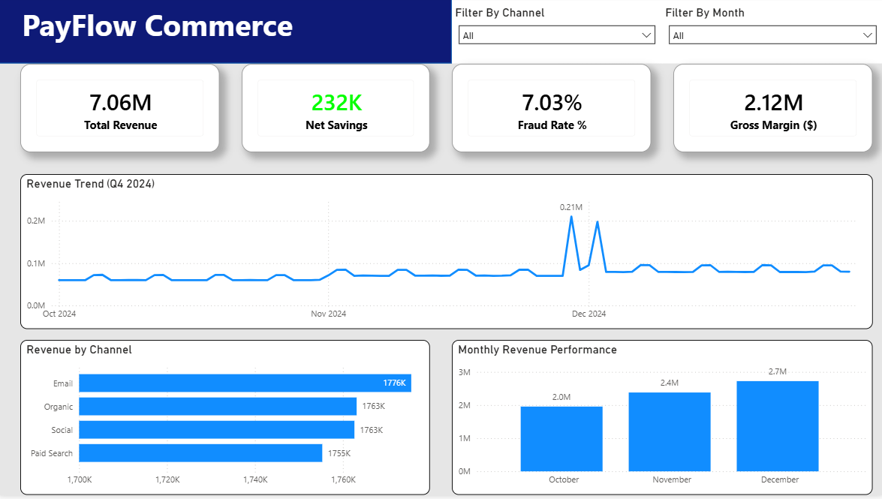
Exhibit C: showing the $232k Realizable Savings.

